**Country Statics Data**

**Description**

This is a module including country names and digit grouping formats, through an API and display the information. The module aims to demonstrate the process of making an HTTP GET request, processing the retrieved data, and presenting it in a user-friendly manner.

**Features**

Country Data Retrieval: The module demonstrates how to fetch country data from the REST Countries API. This includes retrieving information such as country names and digit grouping formats.

API Integration: It demonstrates how to handle the response and extract the JSON data.

Overall, these features enable developers to fetch country data from an API, process the retrieved data, and display it in a suitable format, enhancing the capabilities of their applications.

**Installation**

1. **Download the package from marketplace.**
2. **Import the module package into your project.**
3. **Add Country_Data Overview page to navigation.**

1. **Run application and login with Administrator.**
2. **Now Navigate to the Country overview page.**
3. **A screen shot of a computer

   Description automatically generated with low confidence**
4. 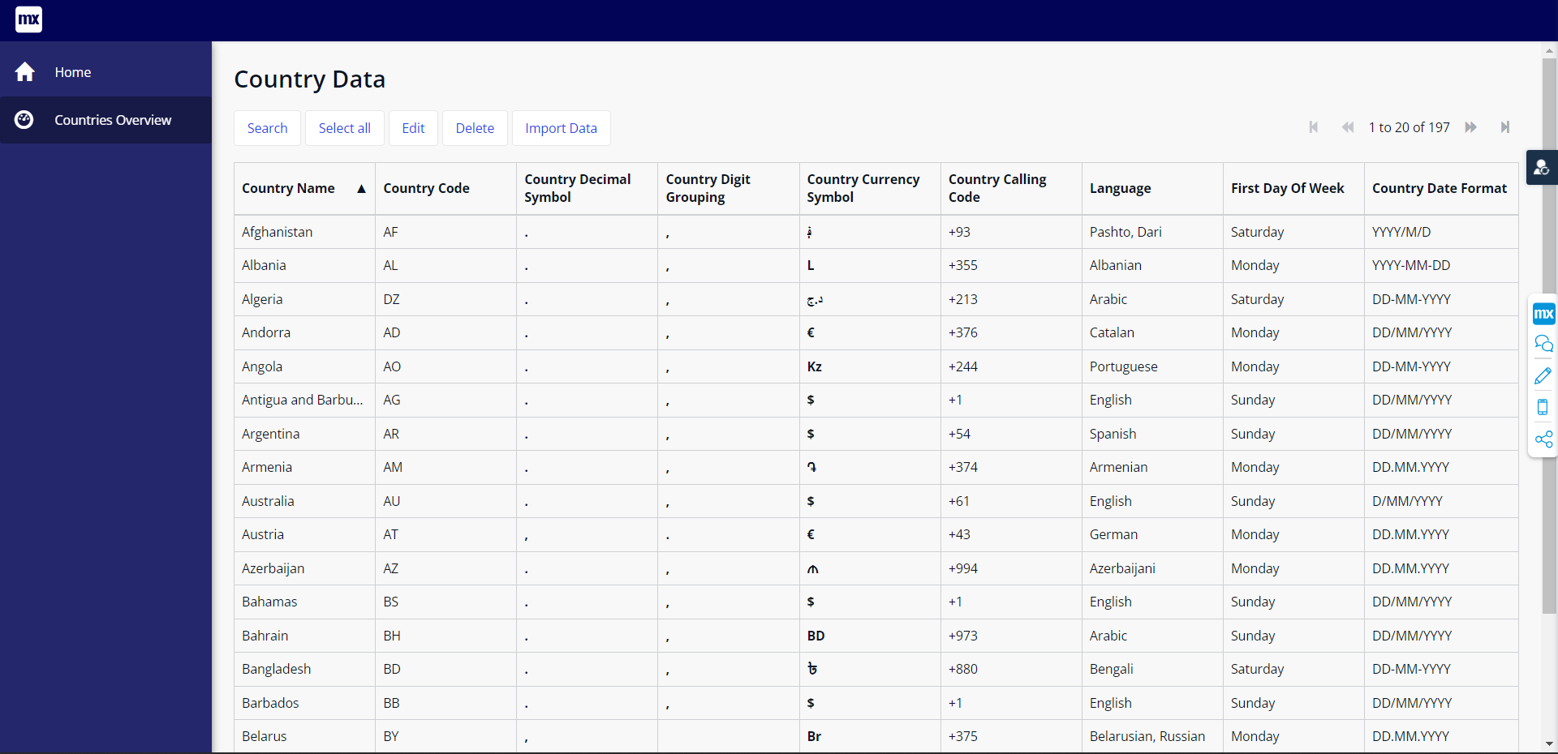
5. **A screenshot of a computer

   Description automatically generated with medium confidence**